Leveraging Text-to-Image Generation Models for Automated Creative Processes in Corporate Marketing

1 Dr. Mrs. Sharmila Sengupta, 2Gauri Nagral, 3Kritika Yadav, 4Meera Sawantdesai, 5Yashraj Mulwani,

1Associate Professor, 2Undergrad Student, 3Undergrad Student, 4Undergrad Student, 5Undergrad Student

Computer Engineering,

Vivekanand Education Society’s Institute of Technology, Chembur, India

***Abstract :***  ***In this day and age, advertisements play a huge role for businesses to flourish in competitive economies. It is said that an attractive ad is worth more than a thousand words. Creating an advertisement involves conceptualizing an idea, designing visual and textual content, and strategically placing it across media platforms to reach and influence the target audience. This entire process can take anywhere from a few hours to several months, depending on the complexity and medium of the advertisement. However, the tremendous growth in technology can turn those hours and months into just a few seconds. This paper explores the capabilities of Generative Artificial Intelligence (GenAI) for visual element generation through advanced techniques. It analyzes leading models like StackGAN, Stable Diffusion - DreamBooth, and LORA, identifying the most efficient among them. The research then focuses on implementing these models to automate advertisement creation for product-based companies, aiming to replace manual efforts in the creative department. The proposed system, ADGenAI offers insights into the transformative potential of GenAI in streamlining creative processes, fostering efficiency, and envisioning the future of the advertising industry. Specifically designed to alleviate the pressures faced by creative teams, such as the demand for high-quality content under tight deadlines, this system enhances creativity and productivity by automating the initial stages of ad production and enabling the exploration of new advertising concepts with minimal resource investment.***

***IndexTerms* - GenAI, Stable Diffusion, GAN, LoRA, Automatic1111 Webui, ControlNet, Additional Networks**

# **Introduction**

Marketing professionals are tasked with interpreting vast amounts of data to tailor advertising strategies effectively. The creative departments within an organization coordinate, execute, and supervise marketing initiatives using various frameworks such as functional, matrix, segment, and product centric approaches. The primary aim is to boost visibility and sales through tasks like formulating strategies, conducting market research, fostering innovation, advertising products, arranging events, and supporting sales teams. In educational resource creation, generative models generate interactive learning materials, personalized study guides, and virtual simulations to enhance the learning experience. In medical marketing, they develop visually engaging content to educate patients and healthcare professionals about new treatments. Additionally, in healthcare and vaccination campaigns, generative AI creates targeted messaging to promote public health initiatives and combat misinformation. These applications, alongside those in art, data-driven fields, natural language processing, and image synthesis, exemplify the extensive impact of generative AI across diverse sectors, fueling innovation while addressing societal and industry challenges. There is a trade-off between manual and automated processes in terms of precision, skill refinement, time and extensive labor. Achieving a balance in these processes is crucial for enhancing productivity and achieving desired results effectively. Digital technologies including programmatic and native advertising have revolutionized modern techniques, requiring marketers to adapt to evolving trends.

Generative AI is reshaping the advertising landscape by automating ad creation tasks and enabling the generation of personalized and targeted ad content at scale. Despite concerns about the quality of AI-generated content, personalized ads created through AI algorithms have shown to increase sales significantly.

The paper details the system's architecture and functionality, aiming to demonstrate its ability to streamline ad creation for creative professionals by offering ease of use, customization, efficiency, and the opportunity for innovation.

# **Literature Review**

The frequently advancing landscape of GenAI has inspired several researchers to investigate their roles in several applications. The study available in paper by Ford et al. (2023) [1] highlights the growing importance of AI in advertising and its implications for both industry and academia. The descriptive data analysis reveals that while AI in advertising research has roots in the past few decades, interest in this domain has experienced noticeable growth. An integrated approach for enhancing design ideation using artificial intelligence and data mining techniques is presented in the study by Chen et al. (2019) [2]. The approach includes two models: a semantic ideation network and a visual concepts combination model. A case study demonstrates the effectiveness of these models in generating diverse cross-domain associations and expediting the ideation process. Unlike the slower iterative evaluation required by other models, StyleGAN-T offers faster generation without sacrificing sample quality. By focusing on lower resolutions, StyleGAN-T proves to be a competitive option [3] for large-scale text-to-image synthesis. The paper[4] provides an overview of text-to-image synthesis techniques, with a focus on diffusion models which have gained prominence in generative tasks. The survey delves into the advancements in text-conditioned image synthesis, exploring related tasks such as text-guided creative generation and image editing. Challenges and future directions in the field are also discussed, alongside considerations for benchmarks and ethics. The authors in paper [5] demonstrated that diffusion models achieve superior sample quality compared to state-of-the-art GANs. They introduce a classifier guidance technique for class-conditional tasks, allowing for an adjustment in classifier gradient scale to balance diversity and fidelity. While diffusion models still require multiple forward passes during sampling, the authors show that combining guidance with upsampling further improves sample quality, especially in high-resolution conditional image synthesis. The authors have introduced Latent Diffusion Models (LDMs) in paper [6] as an efficient approach to high-resolution image synthesis. This approach significantly reduces computational demands for both training and sampling, making it accessible to a wider range of researchers and users. They also introduce a general-purpose conditioning mechanism based on cross-attention, enabling multi-modal training for class-conditional, text-to-image, and layout-to-image models. Pretrained LDM and autoencoding models are made available for various tasks. A neural network architecture, ControlNet designed to enhance the spatial control of large, pretrained text-to-image diffusion models is discussed in paper [7]. ControlNet enables various conditioning controls, such as edges, depth, segmentation, human pose, and more, for Stable Diffusion models. It offers wider applications for controlling image diffusion models, including multi-modal conditions and composition of multiple conditions. In paper [8], a quantitative comparison of three popular generative models, namely Stable Diffusion, Midjourney, and DALL-E 2 is proposed to show their ability to generate photorealistic faces in diverse scenes. The goal is to evaluate these models' performance in generating realistic faces within complex, cluttered scenes.

This research paper presents a novel system that employs GenAI technologies, such as Stable Diffusion (including LoRA and ControlNET), LLM-ChatGPT API, and OpenCV, to innovate advertisement production for product-based companies. By unifying these technologies into an efficient pipeline, the system facilitates the creation of market-ready advertisements from simple text prompts.

# **Proposed System**

It is built around a model trained on a diverse array of product images and captions, enabling easy interaction through prompts. Product images from the "AquaPure" company website were collected for research, forming a dataset with captions for training models with LoRA. These captions were converted into text embeddings using vectorization techniques such as Word2VEC, BERT, and GloVE. The dataset underwent training with specific hyperparameters and a defined noise level, N as shown in Fig 1. Noisy images were processed by a pre-trained diffusion model to predict the noise of N-1 images. This process allowed for a comparison between predicted and actual noise levels, adjusting the LoRA model's gradient weights accordingly. Post-training, the LoRA model supports enhanced prompting capabilities through a GUI developed to simplify user interactions with the model to generate tailored product images. A compelling tagline is an integral part of effective advertising. To achieve this, an LLM is employed to generate a tagline, which is subsequently superimposed onto the generated image.

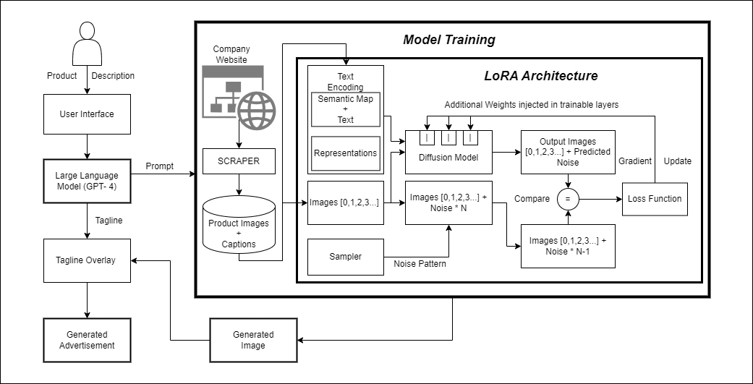

**Fig.1 Architecture diagram of ADGenAI**

Training and testing a LoRA model often requires more computational power than the 8GB Intel(R) Iris(R) XE Graphics Shared Memory. Therefore use of AWS SageMaker, particularly Amazon SageMaker Studio Lab, has been crucial for overcoming these limitations, especially for small businesses. It provides about 4 hours of daily runtime, 15 GB of persistent storage, and access to both CPU (T3.xlarge) and GPU (G4dn.xlarge) resources, along with enterprise-grade security and a user-friendly JupyterLab interface.

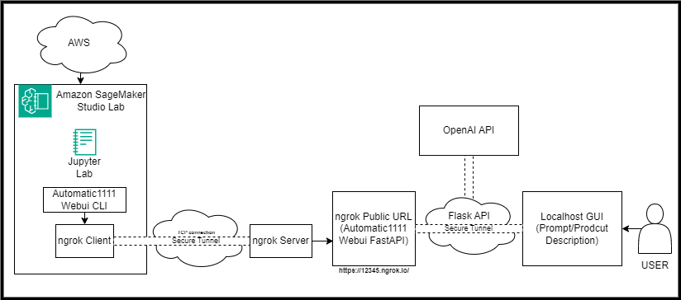

**Fig.2 Process Diagram of the Proposed System**

The Automatic1111 Webui as shown in Fig 2 enhances Stable Diffusion's usability with a web interface that simplifies initiating instances, fine-tuning, and navigating for improved user interaction, also enabling API integration. It supports various synthesis processes and includes extensive documentation for user guidance, promoting creativity and efficiency[9]. For secure external access, A1111 uses launch arguments for establishing a tunnel via ngrok to a public URL, with request processing via a FastAPI on the ngrok server. The OpenAI API further contributes to generating image captions and taglines, key for advertisement creation.

# **Requirements**

The recommended system requirements for the resource area are 2 x 1.8GHz 32-bit (x86) for CPU, with a recommended specification of 4 x 2.4GHz 64-bit (x64) and 4/8 GB RAM. For disk space, new installations require 3.5 GB, and upgrades need 5 GB, including the temporary files required during installation; there is no recommended specification provided for disk space. As for the GPU, the minimum requirement is an NVIDIA RTX 3080, and the recommended one is an NVIDIA GTX1660 Ti. The Software Requirements areReactJS, Gradio, HTML, CSS, JavaScript,Typescript for Front-End Tech Stack; Transformers, Diffusers, Stable Diffusion, OpenAI, GPT2, NeuralNet, Pandas and Numpy for Backend Tech Stack and the Python Libraries used are Web Scraping Tools for example Web Scraper, Tab Save, Image Downloader, Vertex AI etc.

# **Methodology**

This research paper on AdGenAI aims to develop a generative AI model focused on improving advertisement creation for business growth. This involves constructing a user-friendly graphical user interface (GUI) for seamless integration and operation, streamlining workflows for creative professionals for which the different processes for AdGenAI are explained below as in Fig. 3

## **Evaluation of Text-to-Image Generation Models**

This section reviews text-to-image generation models critical for generative AI in creative fields. Highlighted models include DALL-E and DALL-E 2, noted for their large training datasets, and CLIP [10] and Imagen, emphasizing the expansive data they're built upon [11]. Due to the high costs of these advanced models, the focus shifts to accessible options like DeepDaze, DreamBooth, StyleGAN, LoRA, and SNGAN, each with unique capabilities and constraints. DeepDaze, inspired by Google DeepDream, combines CLIP and SIREN for image generation from text prompts but lacks the ability for external training, limiting customization, and achieves an Inception Score of 6.2 [12]. StyleGAN, known for its styling control, is limited in product image generation despite its success in human face datasets, marked by an FFHQ score of 4.40[13]. StackGAN [14] and DreamBooth offer solutions for photo-realism and model personalization, respectively, with DreamBooth achieving a notable Inception Score of 34.9102[15] but requiring significant storage for model updates. LoRA (Low- Rank Adaption) [16] stands out for its efficient fine-tuning and minimal computational cost, making it a preferred choice alongside Stable Diffusion for a wide range of product styles and concepts due to its lightweight and adaptable approach.

## **LoRA and creating the data**

LoRA models are essential in AI, particularly for enhancing creative and design tasks with types including Character, Style, Concept, Pose, and Clothing. These models benefit from integrating proprietary and public datasets, allowing companies to leverage Generative AI without exposing sensitive data. Using a private LoRA model facilitates the blending of company-specific styles with general models, enhancing image generation capabilities

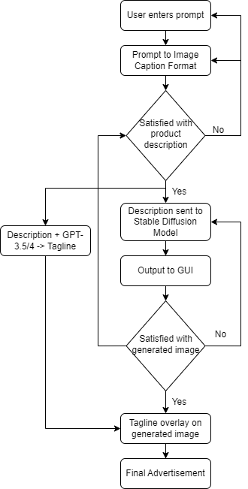

**Fig.3 Flowchart of the Proposed System**

## **The Dataset**

Developing a LoRA model starts with assembling a proprietary image collection that represents the company's intellectual property, complemented by meticulous captioning to ensure AI interpretability. For images**,** the strategy is to start with 10 to 15 high-resolution images per theme, focusing on clarity, relevance, and diversity, and aim to expand the collection to 50 to 100 images to bolster the model's aesthetic range, keeping file sizes below 5GB, thus prioritizing diversity to avoid overfitting and ensure robust learning outcomes. The importance of captions is emphasized by incorporating rare tokens for unique concepts, and ensuring captions convey the intended subject matter effectively. Rare tokens like "skw" act as placeholders for specific concepts, aiding in minimizing pre-existing model biases.

1. **Captioning Insights**

The insights are high-quality, comprehensive captions are crucial for converting textual prompts into accurate visual representations, with balance in quality, quantity, and diversity in dataset curation to optimize training effectiveness and utilize rare tokens for novel or unique concepts to ensure clarity and avoid confusion with existing model knowledge. This can be visualized in Table.1.

**D.1 Without Activation Tag**

**Prompt: <lora:bottle_no_activation_tag-20:1>glass bottle standing straight on ground, night new york times square background**

Using concise captions without activation tags, the model accurately rendered the main object but struggled with complex environmental elements, such as lighting in night scenes. This underscores the model's object fidelity but highlights the need for advancements in capturing complex contexts.

|  |  |
| --- | --- |
|  |  |
| **Without Activation Tag** | **With Activation Tag** |
|  |  |
| **Short Captions** | **Long Captions** |

**Table. 1 Impact of Captions on Image Generation**

**D.2. With Activation Tag**

**Prompt: <lora:bottle_with_activation_tag-20:1>glxbtz standing straight on ground, night new york times square background**

Incorporating activation tags significantly improved the model's rendering of environmental details, like accurately depicting

**D.3. With Short Length Captions**

**Prompt: <lora:bottle_with_activation_short_captions:1>glxbtz, glxbtz standing straight on wooden bench, autumn park background**

Short captions with activation tags allowed the model to accurately interpret abstract cues, leading to precise object depiction and improved contextual detail. This showcases the effectiveness of activation tags in refining environmental understanding without affecting object accuracy.

**D.4. With Long Length Captions**

**Prompt: <lora:bottle_with_activation_long_captions:1>glxbtz, glxbtz standing straight on wooden bench, autumn park background**

Long captions with activation tags resulted in the overemphasis of detailed backgrounds at the expense of the main object's prominence. This suggests a need for balance in detailing objects and backgrounds, highlighting the importance of further research into strategies that ensure the object remains the focus in generated images.

1. **Deep dive into LoRA and parameters**

The hyperparameters used in training, as analyzed in Table 2, are number of epochs and repeats, the batch size, resolution of 512 pixels indicating the size of the images generated or processed and Shuffle tagsto check randomizing the order of data, potentially improving generalization.

**Table. 2 Basic LoRA parameters value guide**

|  |  |  |  |
| --- | --- | --- | --- |
| **No. of Images** | **Repeats** | **Epochs** | **Batch Size** |
| 10 | 10 | 20 | 2 |
| 20 | 10 | 10 | 2 |
| 100 | 3 | 10 | 2 |
| 400 | 1 | 10 | 2 |

The UNet learning rate is 5e-4 and the text encoder learning rate is 1e-4. The Learning rate scheduler mostly used is "cosine_with_restarts" except for aq_train_6, which uses "constant". This parameter controls how the learning rate changes over time. The LR Scheduler Number is used to refer to the number of restarts for the cosine scheduler and LR Warmup Ratio of 0.05 indicates a portion of the training period during which the learning rate gradually increases to its initial value. The common parameters across all trained models are shown in Fig. 4

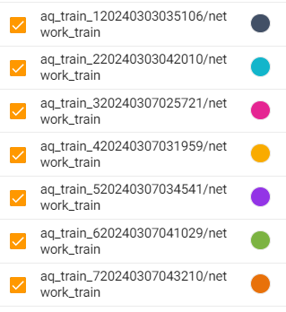 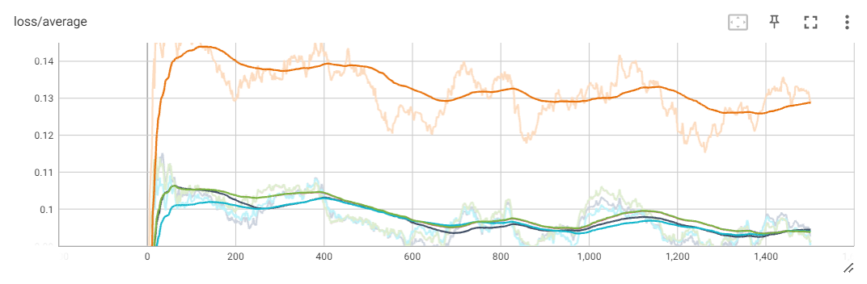

**Fig.4 Color Coded Trained Models Fig.5 Loss/Average of each model**

The Lora Parameters specify the type of Low-Rank Adaptation (LoRA) used, affecting how model weights are adjusted. Different configurations use "LoRA" or "LoCon", indicating different strategies for adapting pre-trained weights and Network Dim: 16, Network Alpha: 8, For LoCon: Conv Dim: 8, Conv Alpha: 4, parameters related to the dimensionality and adaptation rates in the LoRA and LoCon mechanism. Minimum SNR Gamma indicates whether a minimum signal-to-noise ratio (SNR) constraint is applied, aiming to improve model robustness. Most configurations specify "Yes," except aq_train_7, indicating an experiment with turning off this constraint. The Optimizer"none" is specified in most cases but "Prodigy" is mentioned for aq_train_3, for experimenting with a different optimization strategy.

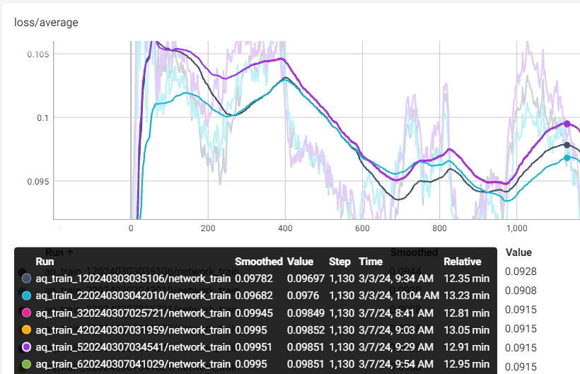 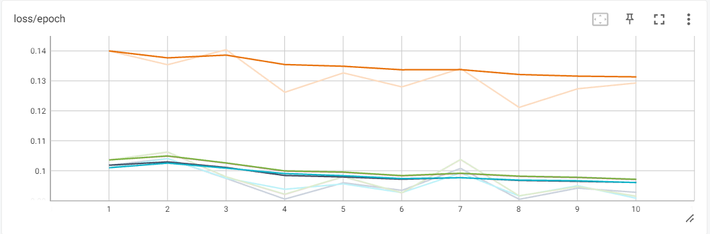

**Fig. 6 Loss/Average of each model indicating** F**ig.7 Loss/Epoch indicating model convergence**

**loss at convergence**

As shown in Fig. 5, a downward trend indicates that the model is learning, i.e the difference between the predicted and actual values is decreasing over time. A flat line indicates that the model has stopped learning, either because it has converged (found the best solution it can) or because it is unable to improve further due to issues like being stuck in a local minimum. “aq_train7” has a very high spike of loss/average throughout training, indicating that the model is underfitting and has a very low performance. This is in line with the fact that the “min snr gamma” parameter is disabled during training of “aq_train_7”. Disabling Min-SNR-γ in denoising diffusion model training could lead to slower convergence and reduced image quality, as this strategy dynamically optimizes the training process by adjusting loss weights based on signal-to-noise ratios, enhancing learning efficiency and output fidelity. Without it, the model may not efficiently navigate the complexity of the diffusion process, affecting performance.The rest of the models other than “aq_train_7” as indicated by Fig. 6 have almost the same learning curve with “aq_train_5” whose base training model is “AnyLora (AnyLoRA_noVAE_fp16-pruned.ckpt)” which is primarily used for Anime Art Styles thus limited in performance for realistic product images, while other models have “Stable Diffusion (sd-v1-5-pruned-noema-fp16.safetensors)”. “aq_train2” however is trained with the LoRA type–LoCon. LoCON is LoRA that works on the convolutional units. All of these models converge around 1300 steps or the 9th epoch.

**F. Parameters in Image Generation, Testing, and X/Y/Z Plots**

Testing image generation models involves assessing their ability to create images based on varied parameters, a process detailed in a specific paper. A key aspect of these models is their use of prompts for controlled image synthesis, with platforms like Automatic1111 offering customization options such as synthesis steps, sampling methods, and the Classifier-Free Guidance (CFG) scale for flexibility in image generation. Visual tools like X/Y/Z plots help analyze the effects of changing these parameters on image outcomes, highlighting the influence of choices like sampling steps or CFG scale on image quality.

In Stable Diffusion, sampling—a sequence of denoising steps—transforms a random latent space image into a coherent one. The process depends on the sampler and noise schedule, with the balance between speed and image quality hinging on the number of sampling steps. While more steps generally improve quality, there's a plateau beyond which quality doesn't increase, emphasizing the need for a balanced approach. The CFG scale determines how closely images adhere to prompts, with higher values ensuring greater fidelity to the input, though values above 7 might not enhance quality further and could introduce artifacts.Fig. 7 X/Y/Z Plot plots Sampling Steps against CFG Scale. There’s obviously visible distortion in images with higher CFG values and lower steps. While steps beyond 20-30 range do not provide any additional benefits to the image quality and CFG scale range from 5-7 is the most ideal range.

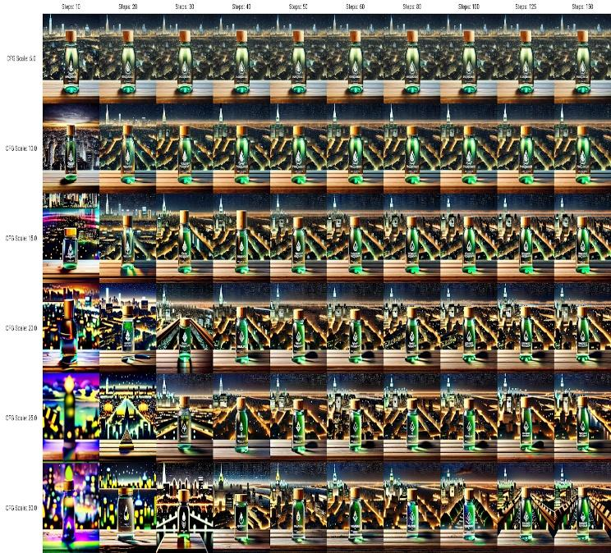

**Fig. 8 CFG value vs. Number of Steps**

Traditional ODE solvers such as Euler, Heun, and LMS, adapted for image generation, offer a trade-off between simplicity, speed, and accuracy. Ancestral samplers introduce randomness, affecting image consistency. The Karras noise schedule enhances image quality by optimizing noise reduction towards the sampling end. Recent advancements like DPM, DPM++, and UniPC improve efficiency and quality through adaptive steps and unified methods. Sampler choice significantly influences the generation speed, efficiency, and perceptual image quality, depending on desired outcomes for convergence, rendering time and visual fidelity.

Few sampling methods used in this paper against CFG scaleare Euler, Denoising Diffusion Implicit Model (DDIM), DPM2 Karras, DPM++ SDE Karras, DPM++ 2M SDE Exponential. Euler is the most straightforward sampler, adopting a deterministic path that offers a balance between simplicity and accuracy in image generation. samplers developed for diffusion models, DDIM strikes a balance between image quality and processing speed, though newer technologies have surpassed its efficiency.

DPM2 Karras leverages a noise adjustment strategy recommended by Karras, aiming for finer image quality towards the final steps of sampling, at a trade-off of slightly reduced speed. DPM++ SDE Karras is a sophisticated approach that combines stochastic differential equations with the Karras noise schedule, aiming for superior image detail and quality. DPM++ 2M SDE Exponential represents the cutting edge in sampling technology, utilizing exponential SDEs to produce exceptionally high-quality images, optimizing both the process's efficiency and the resulting image fidelity.

As indicated by Fig. 9, DPM++ SDE Karras and DPM++ 2M SDE Exponential have a ton of variations in the image batches and many undesired distortions and artifacts. Keeping in mind the speed and accuracy, Euler and DPM2 Karras is the sampling method to be implemented for generating “AquaPure” product advertisements as they have produced consistent results.

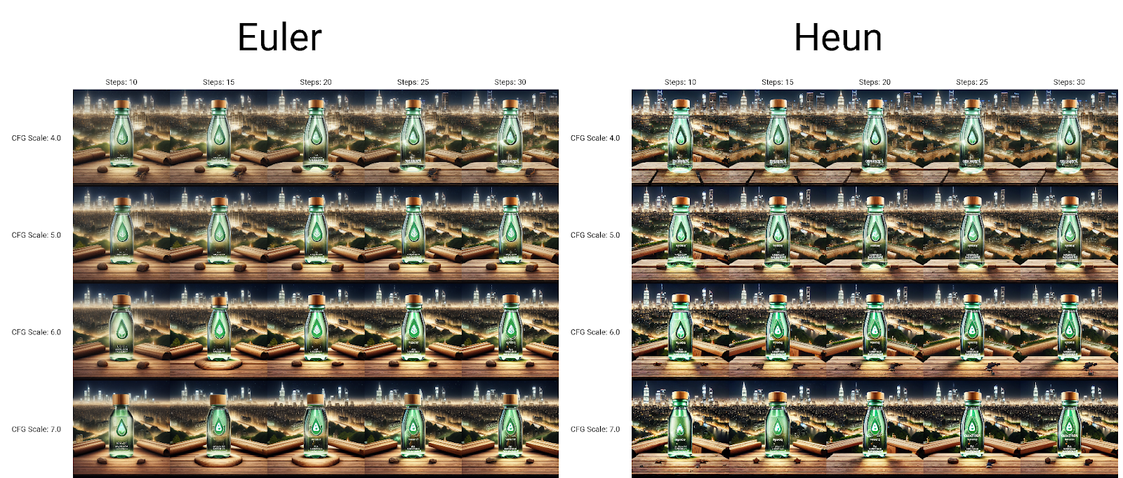 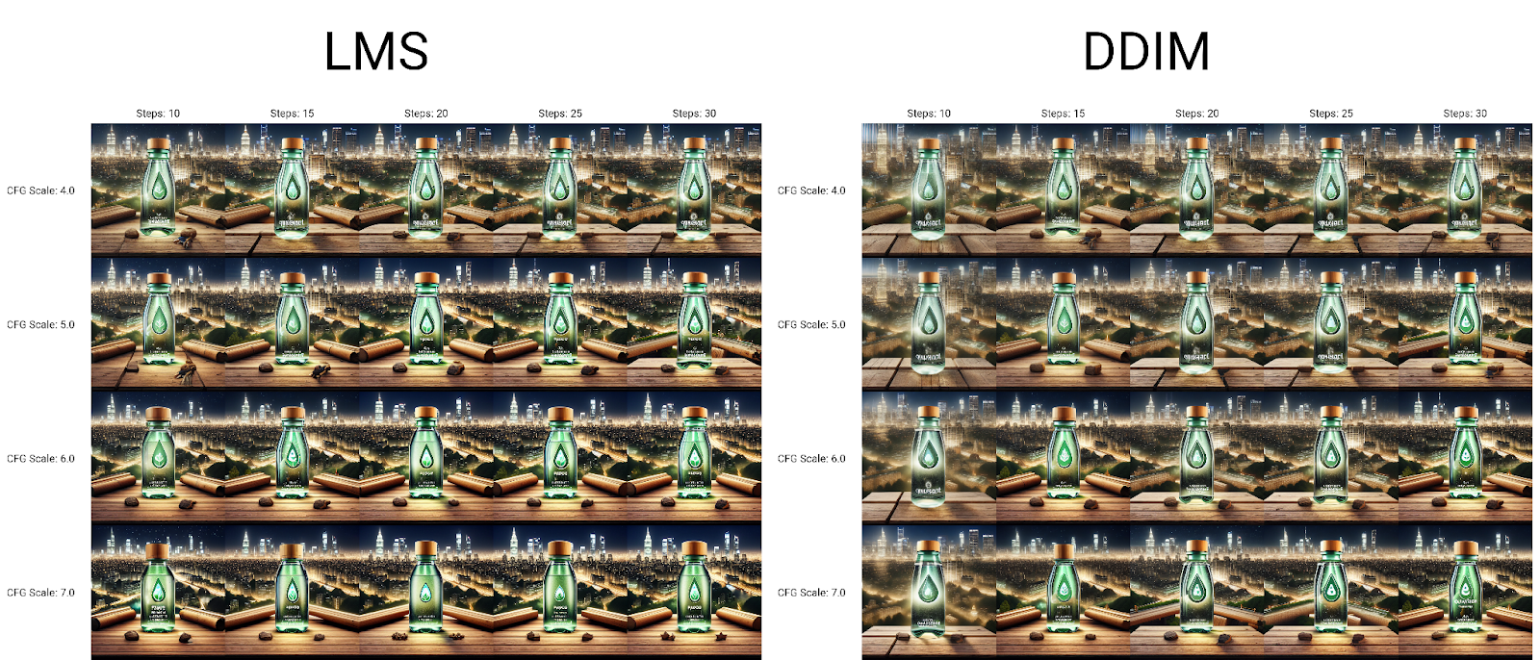

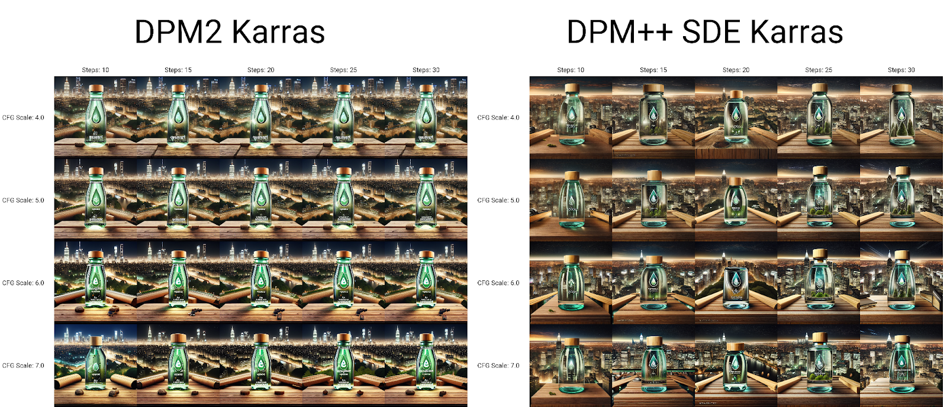 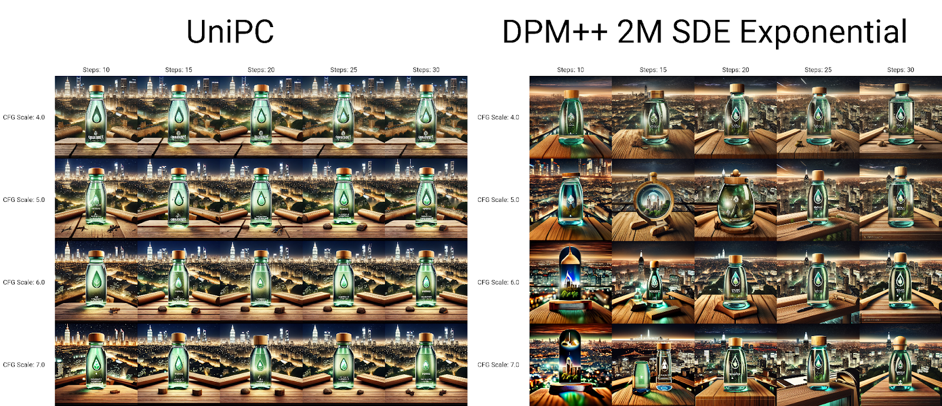

**Fig. 9 Various Sampling Methods X/Y Plot**

**G. Prompts and Prompt S/R and Matrix**

The process of creating prompts is essential for generating high-quality images, involving the strategic use of positive and negative prompts to respectively include or exclude specific terms in the generated images. Assigning different weights to elements within the prompt can influence the importance of these elements in the image generation process. The Prompt S/R (Search/Replace) feature and the prompt matrix tool on the A1111 platform exemplify advanced capabilities in prompt customization. For instance, the ability to replace elements such as "tiffin" with alternatives like "a bag" or "a towel" in a prompt enables the generation of images with diverse elements. These tools not only facilitate the creation of nuanced images but also provide insights into the impact of each prompt component on the final outcome, thereby offering enhanced creative control in creative and marketing applications.

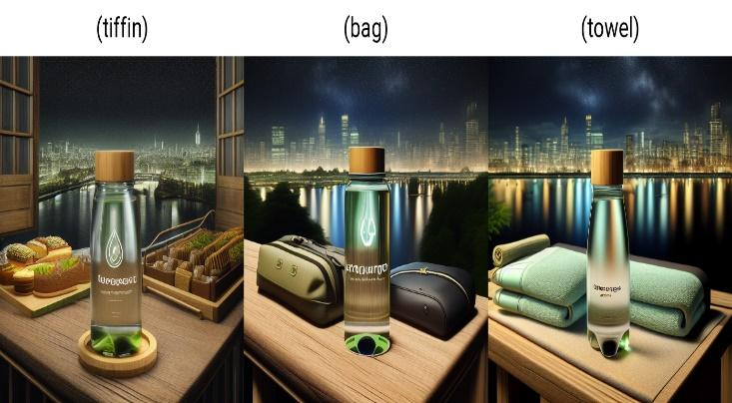

**Fig. 10 S/R matrix with different associative items**

**H. ControlNET and Additional Networks**

This study outlines the development of a LoRA model notable for achieving benchmarks with a CLIP score range of 34.9102 to 36.2137 and an FID score on par with DreamBooth, utilizing proprietary datasets. Although successful in generating product variations across diverse backgrounds, its utility is mainly confined to basic advertising requirements, lacking in delivering narrative-driven advertising that connects with consumer trends and demographics. The research highlights the critical role of engaging design elements in advertising for capturing consumer interest and fostering emotional connections. It suggests employing multiple specialized LoRA models to align with a company's design ethos or reflect current market trends, thereby improving advertisement attractiveness and relevance. The paper proposes a strategy for associative generation, planning to train additional LoRA models on related items (e.g., a glass water bottle with lunchboxes and cooler bags) to craft richer narratives. This integrated model approach seeks to produce advertisements that are visually captivating, thematically coherent, and resonate deeply with the intended audience, in line with foundational advertising principles..

ControlNet, an innovative neural network, augments text-to-image generation in combination with Stable Diffusion by leveraging auxiliary models such as OpenPose, Sketch, and Canny for creating detailed outlines that inform image synthesis. It preserves the foundational parameters of the original model while incorporating trainable encoders for responsiveness to varied inputs. Featuring a U-Net architecture with 25 blocks, including ResNet layers and Vision Transformers, ControlNet methodically enhances image detail. It preprocesses conditioning images into feature vectors through a compact network, ensuring seamless integration with Stable Diffusion for the production of high-quality images tailored to precise aesthetic and structural preferences..

The ControlNET module within the system offers various control mechanisms, including Canny edges, depth perception, normal mapping, and OpenPose for pose estimation. Users can fine-tune the degree of influence through settings such as control intensity and the number of control steps. Preprocessors for each control type allow users to preview masks used in image synthesis. By leveraging multiple ControlNET units, users can enhance image precision, particularly within the AdditionalNetworks unit, facilitating critical guidance for image customization and refinement. This system uses control_v11p_sd15_scribble [d4ba51ff] ControlNET Model for generating the outline/sketch of the original image. As shown in Table. 3, using a preprocessor t2ia_sketch_pidi to generate a preview gives the sketch output.

**Table. 3 Preprocessor Output**

|  |  |  |
| --- | --- | --- |
| ControlNET Module | Seed Image Through ControlNET process | |
| 1 | Original Seed Image | On using Edge Detection |
|  |  |

In the context of Additional Networks,the AUTOMATIC1111 Stable Diffusion Web UI extension expands the original model's functionality by incorporating additional LoRA models, facilitating dynamic improvements in image generation. These models, trained with scripts from the sd-scripts repository, are configured via the "Additional Networks" panel in the Web UI, allowing the use of up to five LoRA models for detailed control over image creation. This unique integration permits precise application of models to specific image areas using mask images, offering targeted modification capabilities. Differing from alternatives like 'Latent Couple extension' and 'Composable LoRA', this extension enables fine-tuned manipulation within the U-Net architecture's layers, utilizing RGB masks to designate regions for applying multiple LoRAs' effects, enhancing the versatility and precision of image generation. RGB Mask of the same control as in the ControlNET module as shown in Fig. 11.

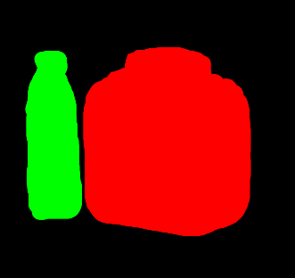 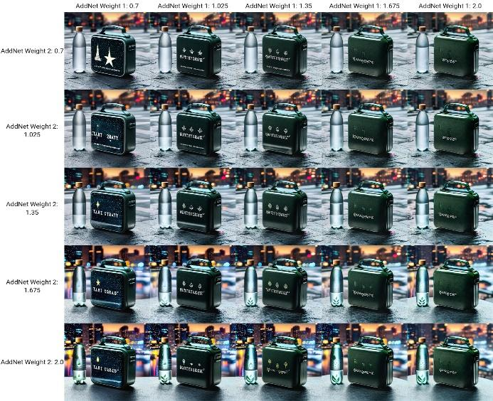

**Fig.11 RGB Mask of Image Fig. 12 Additional Network weights of two models**

By varying the weights of LoRA in both the red and green channels as observed in Fig. 12, such as the LoRA for the "AquaPure" water bottle and the LoRA for the "AquaPure" lunch box, using the X/Y/Z plot, optimal weights for each can be determined. This process helps in finding the best balance between the additional network LoRAs and the prompt.

The masking process involves importing an image, transforming its color space from BGR to RGB for standard color representation, and manipulating specific colors while excluding white to maintain the image's background integrity. By calculating the Euclidean distance to identify and replace dominant non-white colors with a new color set, it creates a mask. This mask is then used with advanced networks like LoRA in a Stable Diffusion framework, facilitating targeted image manipulation for desired aesthetic or thematic outcomes. OpenCV thus acts as a conduit, enhancing neural network-based image synthesis with greater control and nuance.

1. **Tagline Overlay on the generated image**

A study published in the International Journal of Management, Technology, and Engineering [17] emphasizes the importance of incorporating textual information alongside visual content in advertising, particularly for new products. It involves crafting taglines inspired by the company's previous advertising campaigns, with the aid of GPT-4. These taglines are then integrated into the generated images using OpenCV, by segmenting the image to create an RGB mask and overlaying the tagline onto the image area with the largest contour. The text box's coordinates are precisely calculated for accurate placement on the image as visualized in Table. 4. This automated method significantly enriches the advertisement's communicative value by synergizing textual and visual elements, demonstrating an advanced approach to enhancing advertising effectiveness.

**Table. 4 Combining tagline and generated image using background detection techniques**

|  |  |  |
| --- | --- | --- |
| Tagline  Overlay | Generated Image through tagline overlay process | |
| 1 | Background Detection | Text on Background |
|  |  |

# **Results And Discussions**

The Results and Discussion section showcases the system's Graphical User Interface (GUI), designed to guide users through a detailed questionnaire aimed at capturing essential information about the product, including orientation, lighting, and background settings. Upon gathering this data, the system executes various pipelined modules to generate the final advertisement, presenting a novel solution that efficiently utilizes proprietary datasets without compromising company secrets. LoRA emerges as a cutting-edge approach, enabling the seamless incorporation of generative AI into the business landscape, thus optimizing the creative process for advertisement production. This strategic implementation demonstrates a significant advancement in automating content creation, ensuring that the generated advertisements are both high in quality and aligned with the user's specific requirements. This system has achieved satisfactory FID and IS scores. The figures below are the functional and navigational pages of the systems.

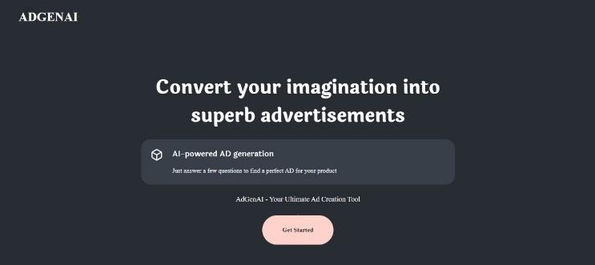

**Fig. 13 Landing page of ADGenAI**

 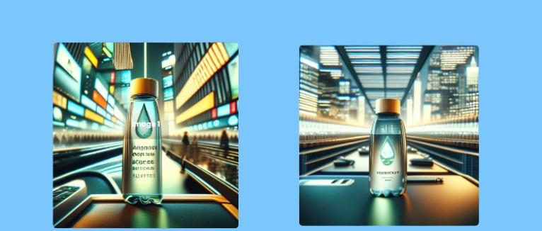

**Fig. 14 Questionnaire to create a prompt based on response Fig. 15 Combining tagline and generated image**

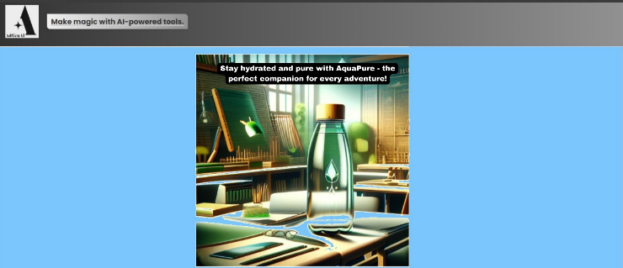

**Fig. 17 Final Advertisement**

# **Conclusion**

The system introduced in this research marks a transformative approach to product-focused corporate advertising by integrating generative artificial intelligence and technologies such as Stable Diffusion (LoRA), ControlNet, Additional Networks, LLM-ChatGPT API, and OpenCV. This development offers a streamlined solution for ad production, blending automation with customization to support creative professionals in generating high-quality advertisements efficiently, while preserving brand integrity and campaign objectives.

The system's innovative architecture and functionalities demonstrate its practicality and potential to shift market dynamics by enhancing the creative capacity of its users, enabling businesses to differentiate in a competitive market and respond to changing consumer preferences.

Prospects for this system include continued innovation in advertising strategies, enabling businesses to produce impactful, emotionally resonant ads. As technology advances, this system is set to lead the evolution of digital advertising creation and engagement.

# **Disclosure statement**

# No potential conflict of interest was reported by the author(s)

# **DATA AVAILABILITY STATEMENT**

The data that support the findings of this study are available from the corresponding author, G. N. , upon reasonable request.

# **AUTHORS PROFILE**

**Dr. (Mrs.) Sharmila Sengupta, Associate Professor** Dept of Computer Engineering, Vivekanand Education Society’s Institute of Technology. More than 27 years of teaching experience. Part of several collaborative problem statements in Artificial Intelligence, Machine Learning, Image processing etc. More than 50 publications in journals and book chapters. Actively engaged in projects with SDG and social causes.



**Gauri Nagral,** final year student at VES Institute of Technology. SE Co-ordinator of VESIT Student chapter of IEEE. Previous Research publication: "Financial Literacy Chatbot" published in May 2023 with an impact factor of 8.176.

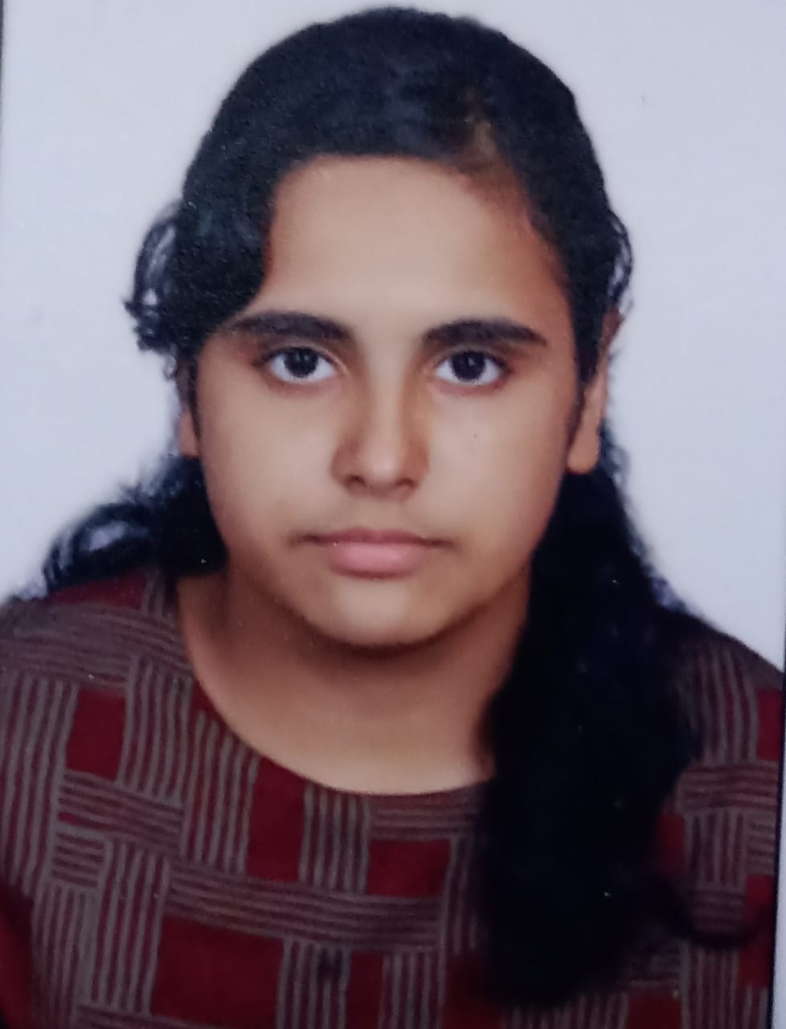

**Kritika Yadav,** B.E Student currently pursuing Bachelor of Engineering in Computer Engineering at VES Institute of Technology, Mumbai, India. Graduated Higher Secondary Education with Diploma Computer Engineering in the year 2021 from VES Polytechnic, Mumbai. Previous Research publication: "Financial Literacy Chatbot" published in May 2023 with an impact factor of 8.176.

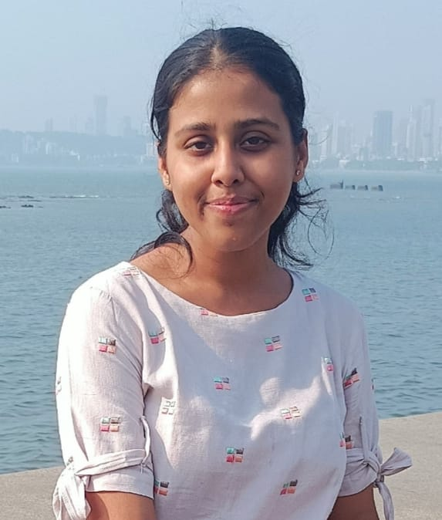

**Yashraj Mulwani,** currently pursuing Bachelor of Engineering in Computer Engineering along with Honors in Artificial Intelligence and Machine Learning at VES Institute of Technology, Mumbai, India. Pursued Higher Secondary education from CHM College, Ulhasnagar. Previous Research publication: "Financial Literacy Chatbot" published in May 2023 with an impact factor of 8.176.

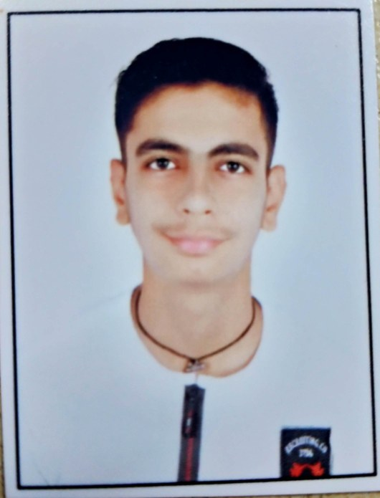

**Meera Sawantdesai,** a final year Computer Engineering student with a passion for AI and ML. Currently studying in Vivekanand Education Society's Institute of Technology (VESIT). Apart from ADGenAI, also contributed to ML project titled "Prediction of road accidents using ML" and also created a "SDN firewall" in TE. Part of VESIT Student Chapter of ISTE since SE.

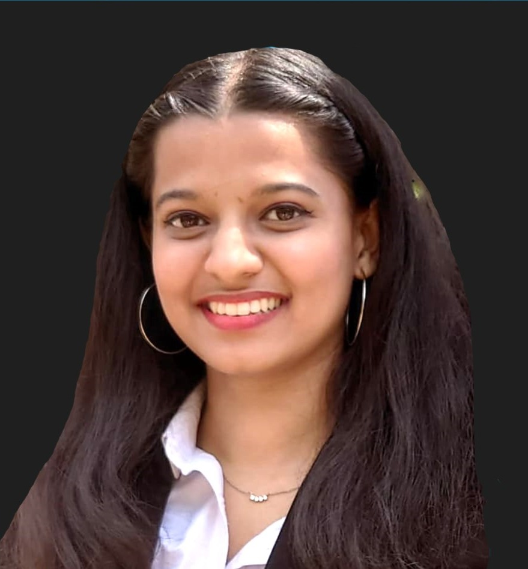

# **ORCID**

Gauri Nagral : 0009-0001-8433-1530

# **References**

[1] John Ford, Varsha Jain, Ketan Wadhwani, Damini Goyal Gupta, ”AI advertising: An overview and guidelines” - Journal of Business Research, Volume 166,2023,114124,ISSN 0148-2963

[2] Liuqing Chen, Pan Wang, Hao Dong, Feng Shi, Ji Han, Yike Guo, Peter R.N. Childs, JunXiao, Chao Wu, “An artificial intelligence based data-driven approach for design ideation, Journal of Visual Communication and Image Representation” - Volume 61, 2019, Pages 10-22, ISSN 1047-3203

[3] Axel Sauer, Tero Karras, Samuli Laine, Andreas Geiger, Timo Aila, “StyleGAN-T: Unlocking the Power of GANs for Fast Large-Scale Text-to-Image Synthesis” - Machine Learning (cs.LG); Computer Vision and Pattern Recognition (cs.CV), arXiv:2301.09515, 2023

[4] Chenshuang Zhang, Chaoning Zhang, Mengchun Zhang, In So Kweon, “Text-to-image Diffusion Models in Generative AI: A Survey” - Computer Vision and Pattern Recognition (cs.CV); Artificial Intelligence (cs.AI); Machine Learning (cs.LG), arXiv:2303.07909, 2023

[5] Prafulla Dhariwal, Alex Nichol, “Diffusion Models Beat GANs on Image Synthesis” - 35th Conference on Neural Information Processing Systems (NeurIPS 2021)

[6] R. Rombach, A. Blattmann, D. Lorenz, P. Esser and B. Ommer, "High-Resolution Image Synthesis with Latent Diffusion Models," 2022 IEEE/CVF Conference on Computer Vision and Pattern Recognition (CVPR), New Orleans, LA, USA, 2022, pp. 10674-10685, doi: 10.1109/CVPR52688.2022.01042.

[7] Lvmin Zhang, Anyi Rao, and Maneesh Agrawala, “Adding Conditional Control to Text-to-Image Diffusion Models”, - Computer Vision and Pattern Recognition (cs.CV); Artificial Intelligence (cs.AI); Graphics (cs.GR); Human-Computer Interaction (cs.HC); Multimedia (cs.MM), arXiv:2302.05543, 2023

[8] Borji, Ali. (2022). Generated Faces in the Wild: Quantitative Comparison of Stable Diffusion, Midjourney and DALL-E 2. 10.48550/arXiv.2210.00586

[9] AUTOMATIC1111, "Stable Diffusion Web UI", 2022-08-22, https://github.com/AUTOMATIC1111/stable-diffusion-webui

[10] Radford, A., Kim, J. W., Hallacy, C., Ramesh, A., Goh, G., Agarwal, S., ... & Sutskever, I. (2021, July). Learning transferable visual models from natural language supervision. In the International conference on machine learning (pp. 8748-8763). PMLR.

[11] Bie, F., Yang, Y., Zhou, Z., Ghanem, A., Zhang, M., Yao, Z., Wu, X., Holmes, C., Golnari, P.A., Clifton, D.A., He, Y., Tao, D., & Song, S.L. (2023). RenAIssance: A Survey into AI Text-to-Image Generation in the Era of Large Model. ArXiv, abs/2309.00810.

[12] P. Wang, "deep-daze," 2021. [Online]. Available: https://github.com/lucidrains/deep-daze. [Accessed: 10- 3-2024].

[13] Karras, T., Laine, S., & Aila, T. (2018). A Style-Based Generator Architecture for Generative Adversarial Networks. 2019 IEEE/CVF Conference on Computer Vision and Pattern Recognition (CVPR), 4396-4405.

[14] Zhang, Han et al. “StackGAN: Text to Photo-Realistic Image Synthesis with Stacked Generative Adversarial Networks.” 2017 IEEE International Conference on Computer Vision (ICCV) (2016): 5908-5916.

[15] DreamBooth: Fine Tuning Text-to-Image Diffusion Models for Subject-Driven Generation

[16] Hu, J.E., Shen, Y., Wallis, P., Allen-Zhu, Z., Li, Y., Wang, S., & Chen, W. (2021). LoRA: Low-Rank Adaptation of Large Language Models. ArXiv, abs/2106.09685.

[17] Mitchell, Andrew A. “The Effect of Verbal and Visual Components of Advertisements on Brand Attitudes and Attitude Toward the Advertisement.” Journal of Consumer Research, vol. 13, no. 1, 1986, pp. 12–24. JSTOR